|  |
| --- |
| **ROSHNI** |
| **4AL15EC072** |
| **8th sem A sec** |

**Report of Day 1**

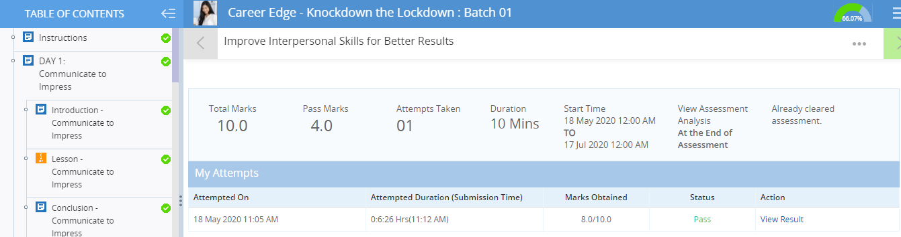

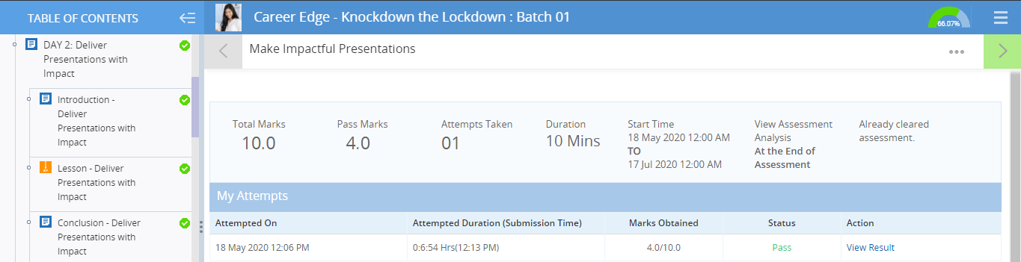

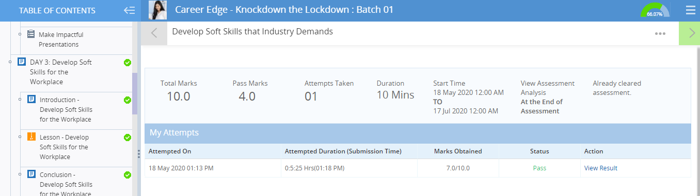

**Communicate to impress**

**Things that Work**

According to White-Earnest, there are some things you can do when dealing with professional contacts that help make your interactions more positive, polished, and easy. These are a few:

* **A hand-written thank you note after a good interview.**This helps you stand out as a candidate and shows your sincere desire to earn the position. Some people are tempted to text after a job interview because they want to get in touch immediately. While immediacy is important, you can accomplish this by sending an e-mail and then follow up with your hand-written letter.
* **Use good posture and smile when talking on the phone.** The person on the other end of the conversation may not be able to see you, but scholars of communications find that these behaviors make a real difference in the way you are perceived. By sitting up straight and smiling, you can help ensure you leave a positive impression. You can even put a mirror in front of your face when on an important call to ensure you convey your meaning with the appropriate expression.
* **Make sure your personal phone is job search/office ready.** Ensure you have a basic ring tone and voicemail greeting that projects an image of professionalism.
* **Turn your personal phone off**whenever you are in interviews, meetings, or other professional settings. Not doing so is disruptive and makes you seem unorganized.
* **Fully read all of your e-mails and reply appropriately.** Do not skim! Address each point that is brought up. If a person brings up three issues, don’t address only two. If you cannot answer all of their questions, tell the person you will find out the information they are seeking and get back to them.
* **Use auto responder when on vacation or at a conference.** That way if you don’t get back to someone right away, they will not be left to wonder why you didn’t respond or assume you are nonresponsive and unreliable.
* **Be sure to have an e-mail signature.** This should include all of your contact information and a link to your LinkedIn profile. That way the person will be able to easily contact you in terms with which they are comfortable.
* **Respond even when you’re not interested**. If you receive an e-mail requesting an interview for a position you’ve decided you do not want, don’t ignore it. Write the person back, thank them, explain that you don’t think it’s the right position for you, and if you know someone who might be a good fit, mention that person and put them in touch. That way, if an opportunity that does suit you opens up within their company, they will remember your courteous communications and helpful attitude. If you ignore them, consider the bridge burned.
* **Make sure all of your social media profiles are up-to-date and thorough**. You want to be sure that anything they check really shows what you bring to the table. And they *will*check!

**Things that Don’t Work**

Just like there are things that help your work image, there are also actions that can harm it. Below are some to avoid:

* **Initiating text messaging.** Generally speaking, you should never initiate texting with a professional contact. They should text first and then it is okay to answer them. However, just because they texted first, this time, doesn’t mean it is okay to use text the next time you need to communicate with them. E-mail or phone should still be used. Texts should be on a response-only basis in the professional sphere, unless specified otherwise by the contact.

Note: About 60% of recruiters use text. This is because 98% of texts are opened and 90% are replied to in 3 minutes. They know if they text they will probably hear back from you quickly, which is an advantage when they are scheduling multiple interviews. While it is obviously fine to respond to these texts, it is important to remember that other communications should take place via e-mail or phone – never text.

* **Text talk, social media abbreviations, and emoticons should not be used in job search materials.**These are simply too casual and personal. Plus, many people will see you as juvenile, LOL. 😉
* **Misspelling the contact’s name or addressing them as the wrong gender.**These types of mistakes are a great way to make a bad impression. This is especially important when the stakes are high, as in job search e-mails or when writing to a superior. If you are writing to that person, chances are you want them to help you in some way. Take the time to find the person on LinkedIn or their company website to determine their correct name spelling and whether they are male or female. Note: never assume you know gender by name!
* **Emails without subject lines.** Always make sure to write a clean, accurate subject line for your e-mail. Emails without subject lines sometimes end up in spam folders. Subject lines also help your e-mail to stand out and be searchable if someone wants to reference the information in it later.
* **Applying to jobs for which you are unqualified.** Recruiters get hundreds and hundreds of applications. Wasting their time by applying to a job for which you don’t qualify is a surefire way to ensure that company never hires you. Of course, more qualifications are possible with an [online bachelors degree](https://www.trident.edu/bachelors-degree-online/).
* **Not proofreading and spellchecking.** Errors will project an image of carelessness when you want to come across as detail-oriented. Sending sloppy communications is also somewhat disrespectful as it indicates you don’t care enough about them to ensure your communication is correct and professional.
* **Following up more than once or twice per week.**If you’ve written your follow-up e-mail clearly and appropriately, you will probably not have to do this anyway. But if you find yourself attempting to contact a company on a more than bi-weekly basis, you should probably realize this opportunity is not for you and move on.

In addition to these dos and don’ts, White-Earnest says there is one thing that will help you earn favor more than anything else in business communications: “The most important thing is to make connections and build relationships,” she said.

In the words of Maya Angelou, “people will forget what you said, people will forget what you did, but people will never forget how you made them feel.” If you made your contact feel friendly, at ease, and confident in your abilities, then you are well on your way to success

**Deliver presentation with impact**

* Design effective PPTs, Make an effective presentation, Dos and don’ts in presentation skills
* 5W’s
  + - What
    - Who
    - Why
    - Where
    - When
* A few image per slides
* One thought per slide
* Effective use of quotations
* Readable fonts
* Avoid upper cases
* Attractive slides
* Use images to simplify content
* Background to be simple
* Use visual aids
* Formally dressed
* Knowledge transfer
* Team meeting
* Brain storming

**Develop soft skills for the workplace**

* Importance of soft skills, Distinguish hard and soft skills
* Lack of soft skills
* Need for soft skills
* Recognizing the need for soft skills
* Importance of soft skills
* Difference between soft and hard skill

**SOFT SKILLS AND HARD SKILLS**

**What Are Soft Skills?**

**Soft skills definition:**We define soft skills as abilities not unique to any job. Are you a great communicator? Do you collaborate with others like Steve Rogers? Those are softer skills.

### ****What Are Hard Skills?****

**Hard skills**are teachable abilities or skill sets that are easily measurable. We define hard skills as the [technical abilities](https://zety.com/blog/technical-skills) that fit the job. Normally, you can acquire hard skills in the classroom, in an online course, through books and other materials, or on the job.